Lego Boat Supply Ordering Information:

You can order all supplies for the Lego Boat assembly from www.lego.com. On the website, you can custom-order individual bricks in specific amounts. The table below includes direct links to the bricks. The table also provides Part ID numbers and Lego’s color name to make searching easier if the links change on Lego’s website. Note: Part ID numbers are specific to the type of brick (2x1, 3x2, etc.) and are not specific to the color of the brick. However, you can filter by color on the Lego website.

Please allow 15 business days for shipping within the continental US. Please allow more time for overseas shipping.

CONTENTS PER KIT
RED BRICKS | BLACK BRICKS | YELLOW BRICKS | WHITE  BRICKS | MISC
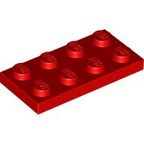  1 (4 x 2) flat  ID: 302021/3020  -Bright Red  Click to order | 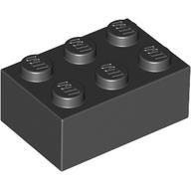  2 (3 x 2)  ID: 300226/3002  -Black  Click to order | 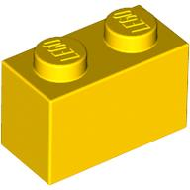  4 (2 x 1)  ID: 300401/3004  -Bright Yellow  Click to order | 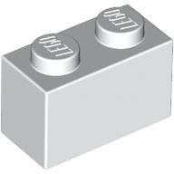  2 (2 x 1)  ID: 300401/3004  -White  Click to order | 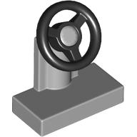  1 grey steering wheel  ID: 4226995/73081  -Medium Stone Grey  Click to order
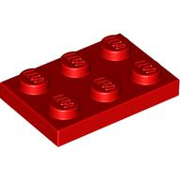  2 (3 x 2) flat  ID: 302121/3021  -Bright Red  Click to order |  | 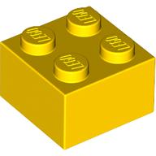  1 (2 x 2)  ID: 300324/3003  -Bright Yellow  Click to order | 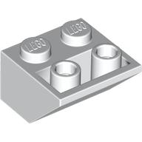  1 (2 x 2) slanted  ID: 6366391/76959  -White  Click to order
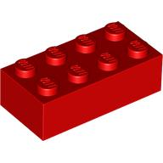  1 (4 x 2)  ID: 300121/3001  -Bright Red  Click to order |  | 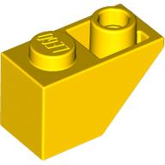  2 (2 x 1) slanted  ID: 366524/3665  -Bright Yellow  Click to order
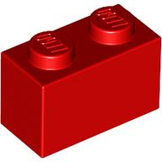
2 (2 x 1)
ID: 300401/3004
-Bright Red
Click to order

